Committee (Self recommendation or recommendation)

世界中联套针专业委员会成员申请表(自荐或推荐)
Name of the Specialty Committee and Working Committee： 拟加入的专业（工作）委员会：套针专业委员会
Name 姓名 | 李明伟 |  | Educational Institution& Degree  最后学历及毕业院校 |  |  | 北京中医药大学 |  |  |  | 1 Inch Photo  一寸证件照  （提交电子版照片）
Sex 性别 | 男 |  | Major and Specialty  专业及专长 |  |  | 针灸推拿
Birth Date  出生年月 | 1986.06.05 |  | Professional Title  职称 |  |  | 主治医师 |  | Job Title  职务 |  | 医生
Language and Proficiency  使用语种及熟练程度 |  |  | 汉语 |  |  |  |  | Country  国别 |  | 中国
Work Unit  工作单位 | 北京市朝阳区XXXX医院 |  |  |  | Fax No.  传真 |  |  | Telephone No.  电话
Mailing address 通讯地址 | 北京市朝阳区工体北路X号院X单元X楼（本人邮寄地址） |  |  |  | E-mail  电子邮件 | 185182XXXXX@.163com |  | Mobile  手机 |  | 185182XXXXX
Brief introduction to your professional career 个人学习、工作经历
Time 时间 |  | Work Unit 单位 |  |  |  |  |  | Job Title 职务
2005.09—2009.7 |  | 北京中医药大学针灸推拿学院 |  |  |  |  |  | 学生
2010.05—今 |  | 北京市朝阳区XXXX医院针灸科 |  |  |  |  |  | 医生
Academic achievement & Main Papers and publications 学术成就及主要论著：
Opinion from your unit  所在单位意见  同意  Signature／0fficial seal  (签名、盖章)  Date:  2021 年 4 月 22日 |  |  |  | Title in Committee  拟任会内职务 |  |  |  |  | Comments and Seal of WFCMS  世界中医药学会联合会审查意见及签章：
Signature of Chairperson
(会长签名)

Date:

年 月 日
Note: Please fill the form in both Chinese and English, and have the form stamped by your work unit’s Personnel Department. Submit electronic photo, and a photocopy of your identification certificate. The line width can be adjusted according to contents.
注：表格中英文填写，加盖本单位人事章，交表附本人电子证件照 1 张（照片名称注明姓名）及身份证扫描件
（含身份证正反面），行数不够请自行添加。

本人照片 职称证（有提交，没有可以不提交）

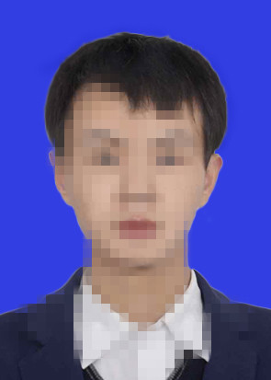

身份证
